From Source Code folder (not necessary needed)
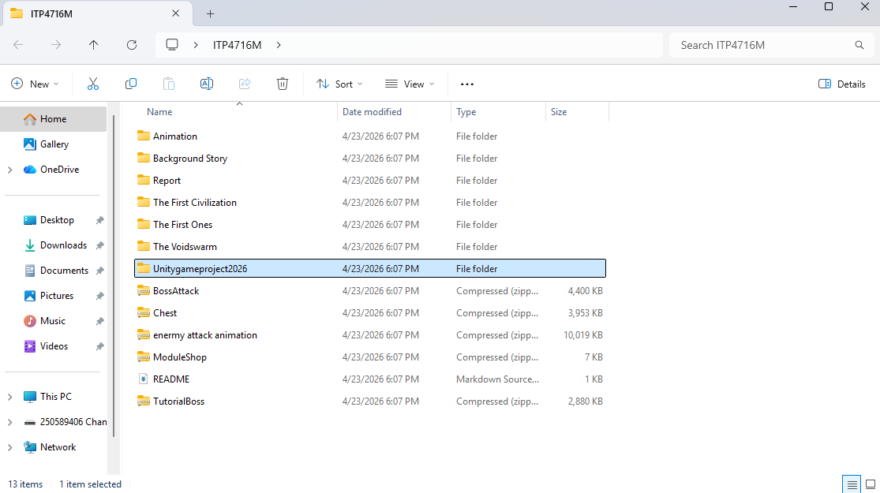
Click into this

From Unitygameproject2026 folder
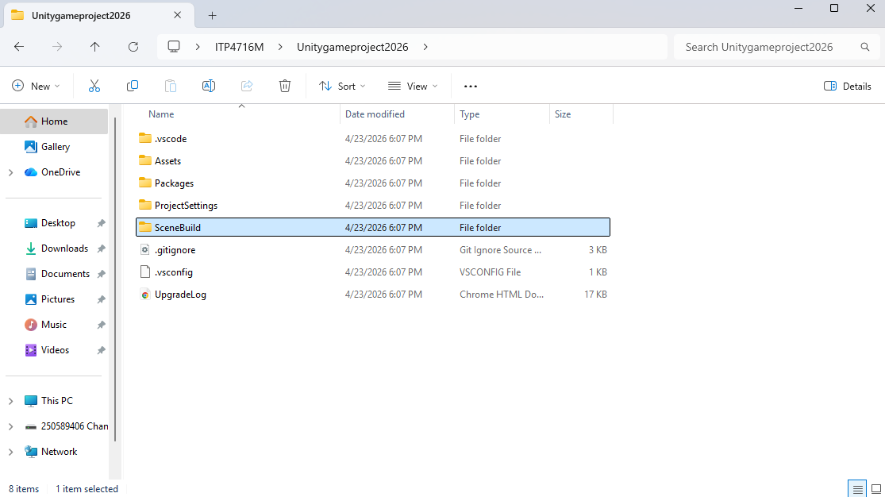
Click into this

From SceneBuild folder
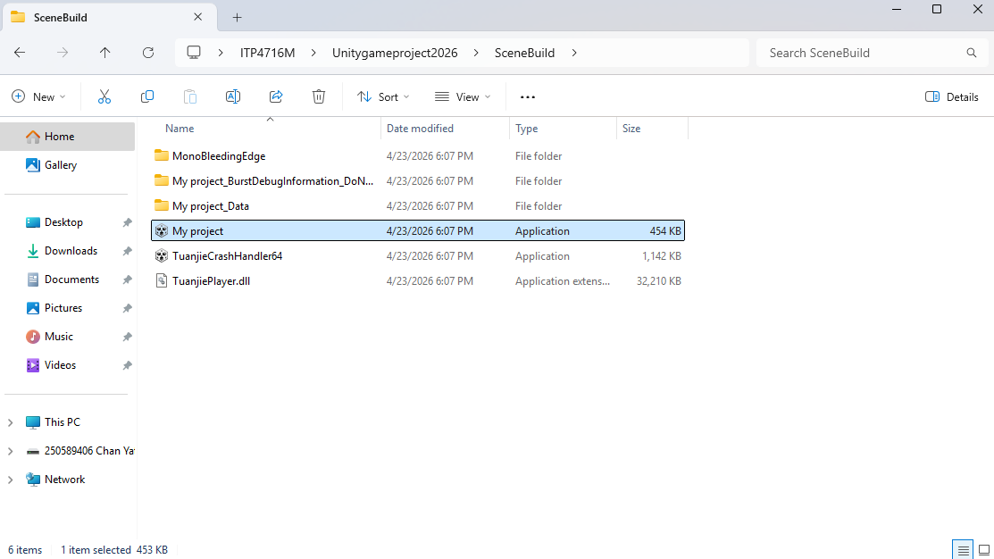
Open this

